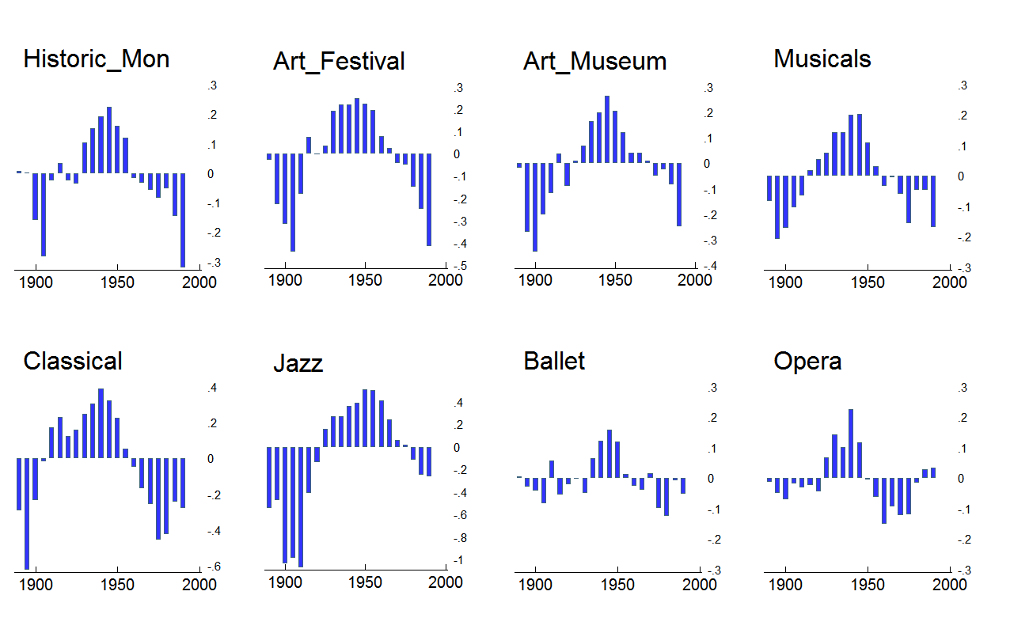Figure 1. Area chart of age and period-adjusted effects of cohort-group membership on arts participation for the eight core SPPA activities.

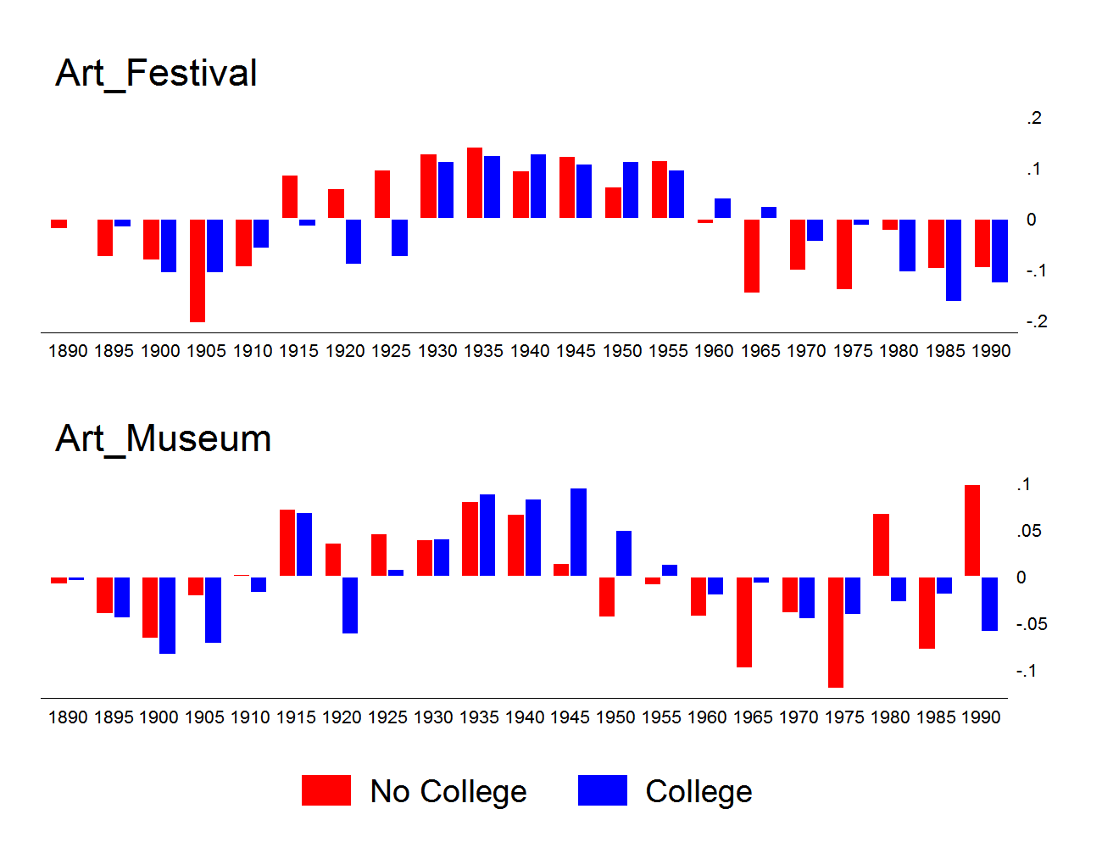
Figure 3. Bar chart of normalized cohort effect (θ_{j}) on Art Festivals/Craft Fairs (top panel) and Art Museums (bottom panel) participation for college and non-college educated respondents, 1982-2012 SPPA.

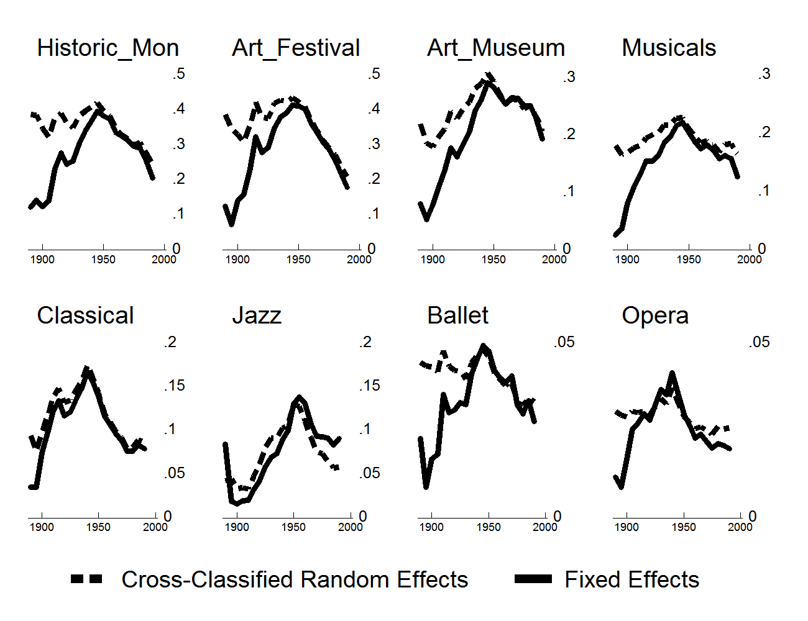
Figure 4. Line plots comparing predicted cohort trends in arts participation from cross-classified random-effects and fixed effects HAPC models. Panels ordered (from top left to bottom right) according to overall popularity of activity.

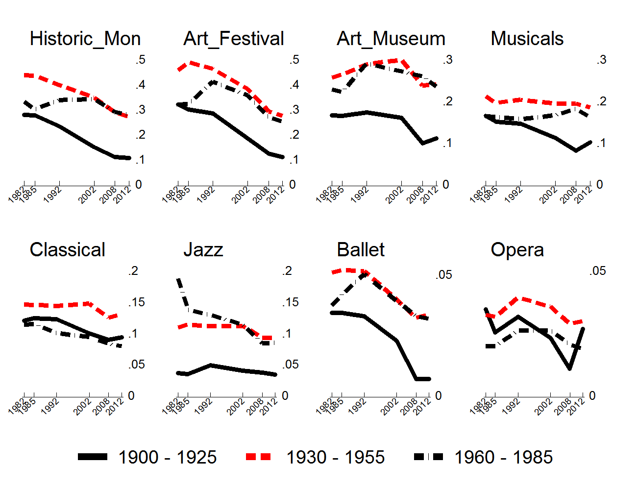
Figure 5. Graphical plot of arts participation frequency by survey year and HAPC-derived cohort group categories, 1982-2012 SPPA. Panels ordered (from top left to bottom right) according to overall popularity of activity.

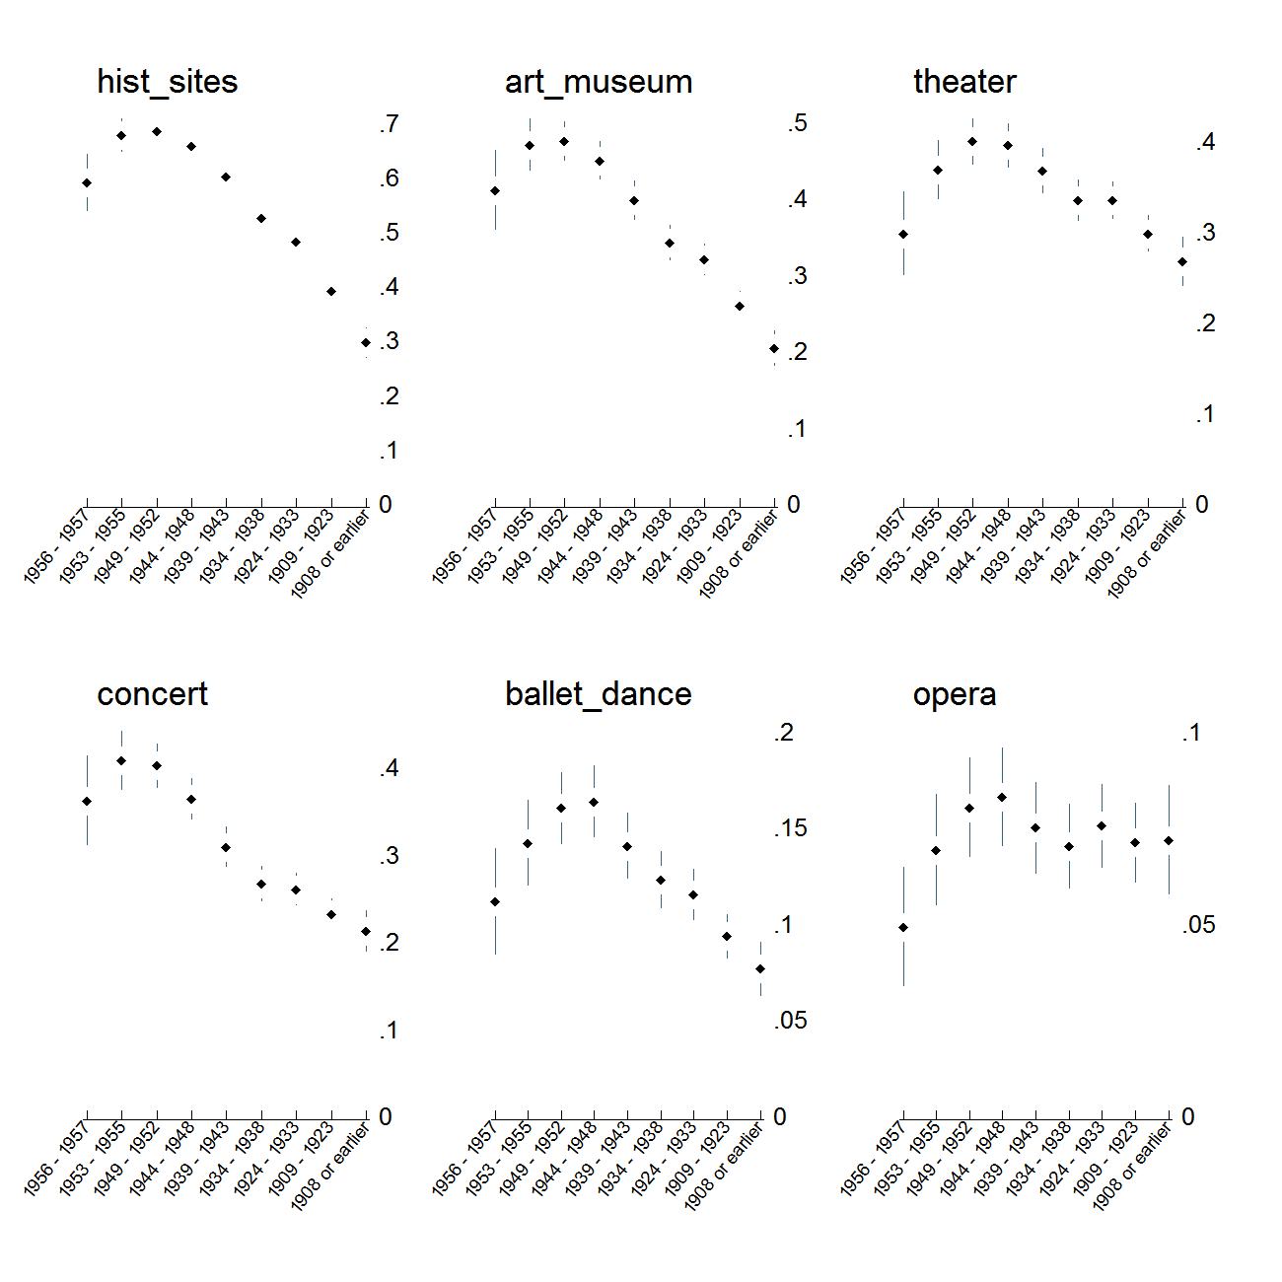
Figure 6. Predicted probability of exposure to the arts while growing up for members of different cohorts. Estimate are obtained from ordered logit models predicting having been exposed to the arts “often,” “sometimes,” “hardly ever,” or “never.” Plots show the additive probabilities of the first two responses adjusted for respondent's race, education, gender, and region of residence. Cohort effects are specified using both a linear and a quadratic term. Panels ordered (from top left to bottom right) according to overall popularity of activity.

